**Module 2 Assignment – ES6 Modern JavaScript- Notes**

Sasanka Vepakomma

Ira A. Fulton Schools of Engineering, Arizona State University

IFT 598: Middleware Programming & Database Security

Prof. Dinesh Sthapit

Due: Sept 17, 2022

**Module 2 Assignment – ES6 Modern JavaScript- Notes**

Commands/Concepts learned:

* const httpServer = require(‘http’) // require method imports the input package along with the relevant methods
* const replaceTemplate = require(‘./modules/replaceTemplate’) // imports the content from a file that user created. This requires the created file to export the method using module.exports call
* const tempCourse = fs.readFileSync(‘${__dirname}/data/data.json’, ‘utf-8’) // readFileSyn method reads content from an input file. __dirname refers to the parent directory in which the js file is placed
* const dataObj = JSON.parse(tempCourse) // converts string to JSON object
* httpServer.createServer((req, res) => {}) // createServer method creates a server
* res.writeHead(status, content-type) // gives out the status file in the network tab like 404 error or status 200 ok.
* JSON.stringify(course) // stringify method converts an input object (number, JSON, etc.) into a string
* console.log() // outputs anything given in the log method to the console
* server.listen() // listen method makes the server listen to the inputs in console. Has port number, hostname and call back function as input parameters
* dataObj.forEach() // iterates across each object in the dataObj array
* element.field = value // creates a key in element JSON object and assigns it with value

Screenshots:

Output:

Console: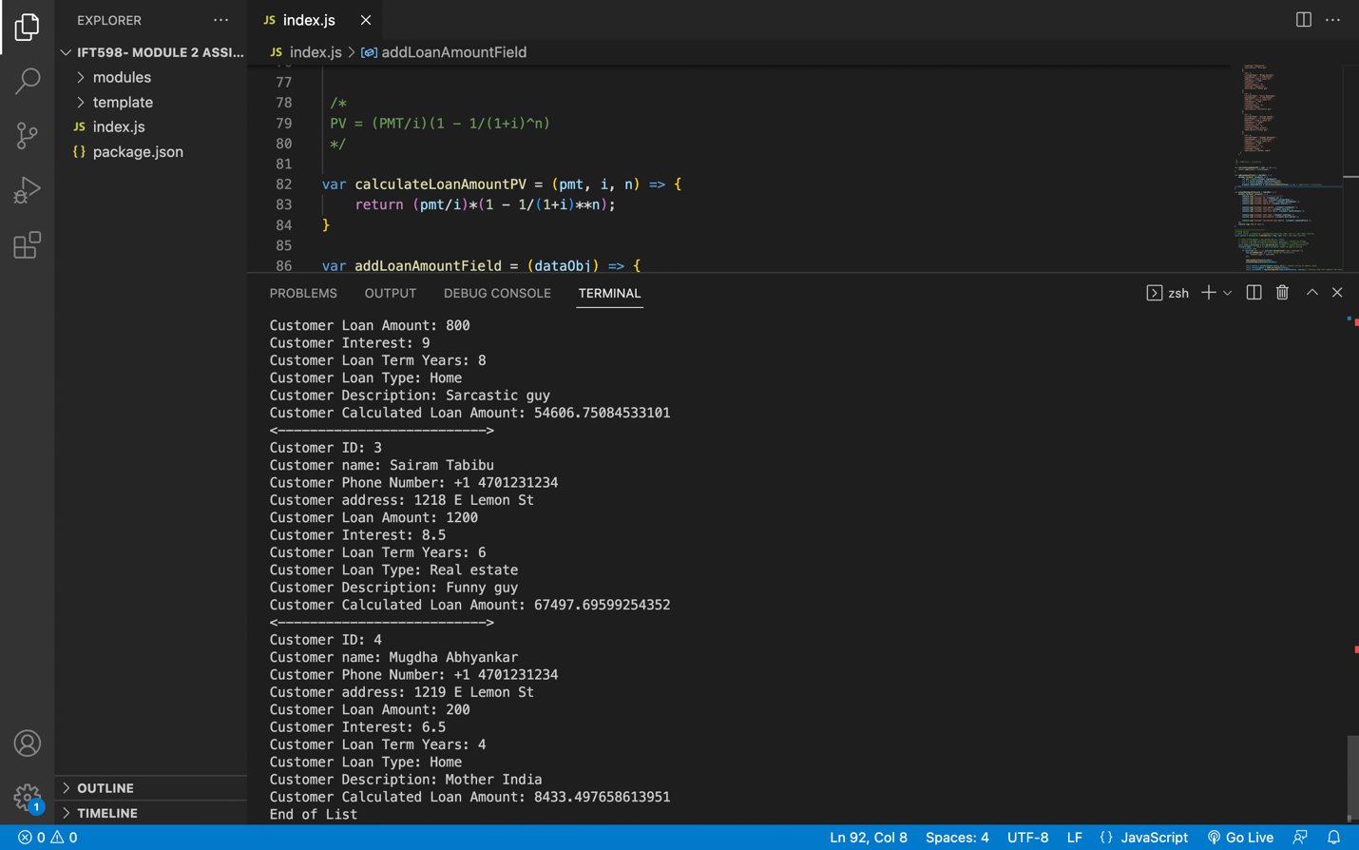

GitHub link:

<https://github.com/vsasanka/IFT598MiddlewareProg-DBSecurity/tree/main/Module%202%20Assignment:%20ES6%20Modern%20JavaScript>